American shopping malls

Where people live vs where they shop, how this affects the development of suburbs and changes to downtown.

Au Bon Marche considered to eb first department store in 1876, started a shjopping revolution by introducing price tags rather than using bartering, you knew you were getting the same price as everyone.

Marshall fields wholesale store and carson pirie scott in Chicago were examples of retail buildings.

Early 1900s department stores

1954, congress attempted to stimulate investment in manufacturing by accelerating the depreciation process for new construction. Allowed people to recoup losses in significantly less time. (40 yrs to 7)

Result was a bonanza for developers.

After building a mall, income could be offset by ‘depreciation’, allowing developers to not pay taxes on that income. They technically had a lot of debt.

Victor Gruen big boy in shopping mall industry

Brought urban elements to the suburb that he thought of as a ‘hellish landscape’

Malls were designed to block out the outside and keep people there as long as possible

Idea was people would move into homes near malls

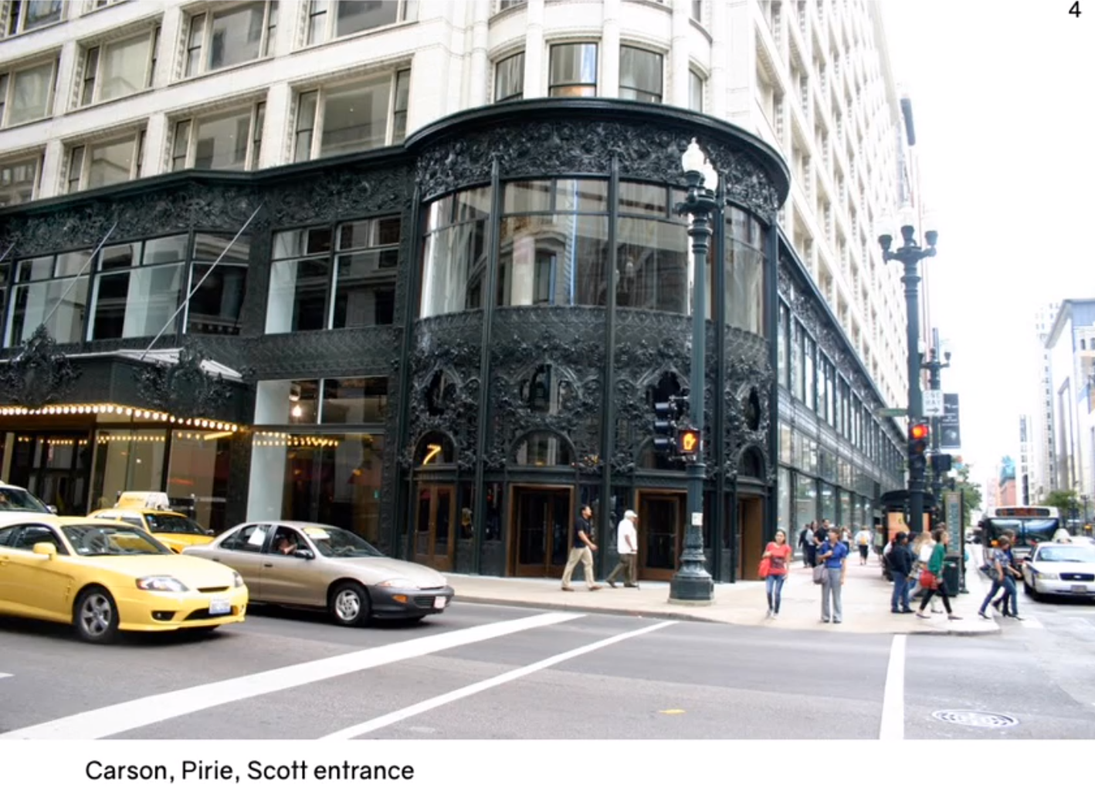

Detailed entrance, contrasts white building.

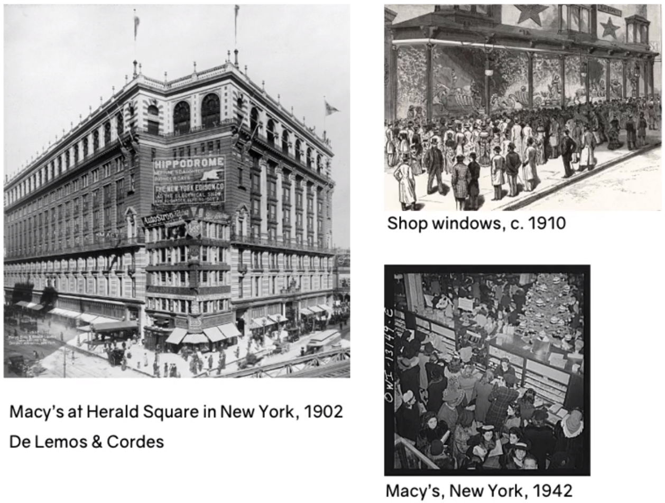

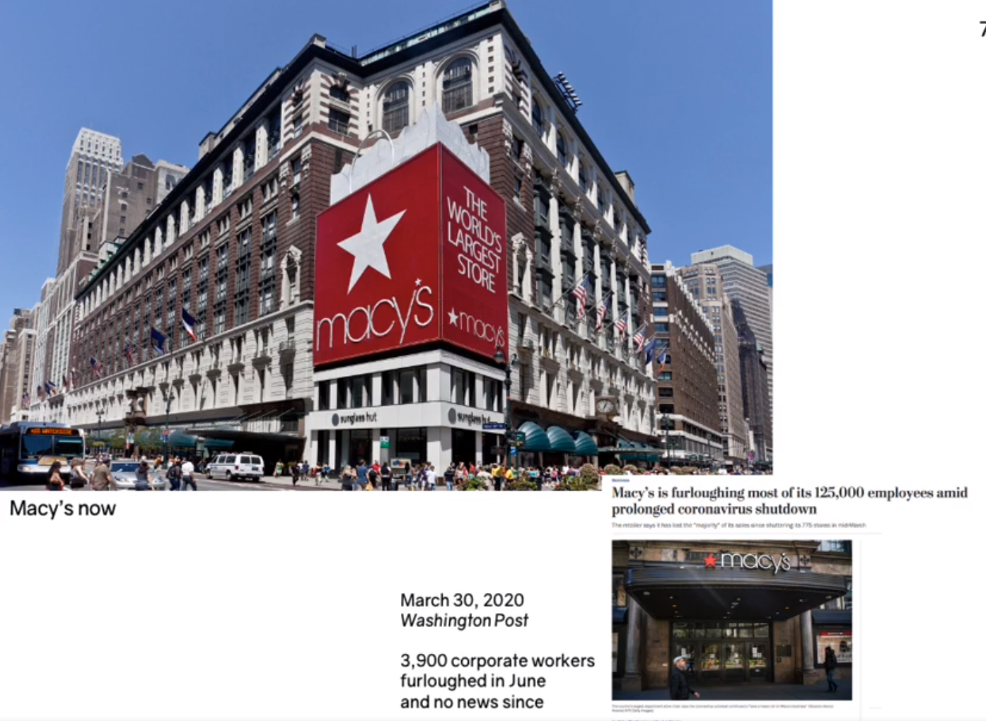

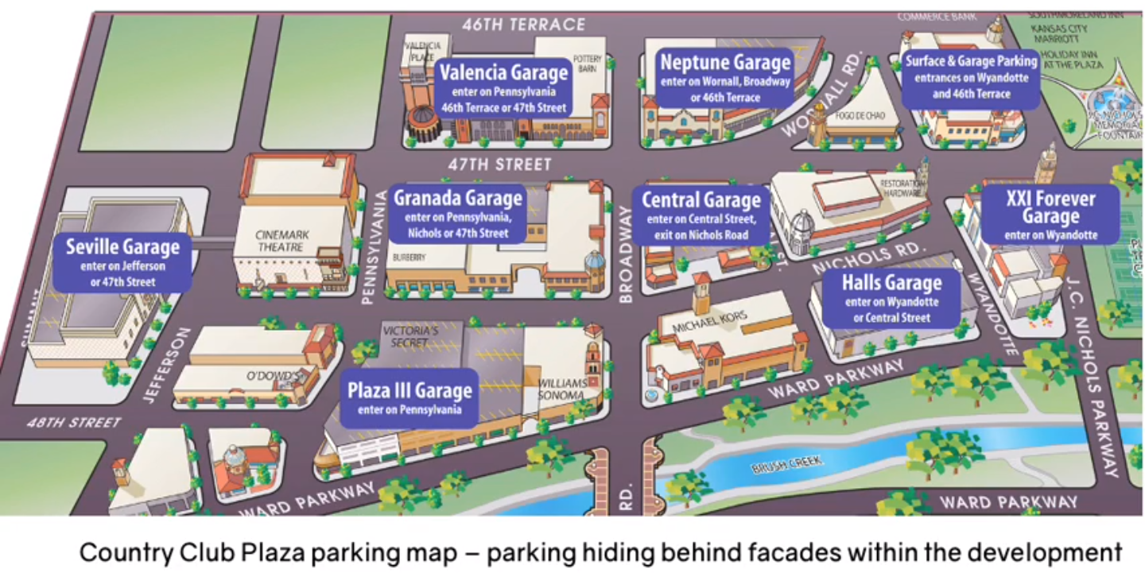

An idea for an outdoor style mall (malls weren’t a thing yet)

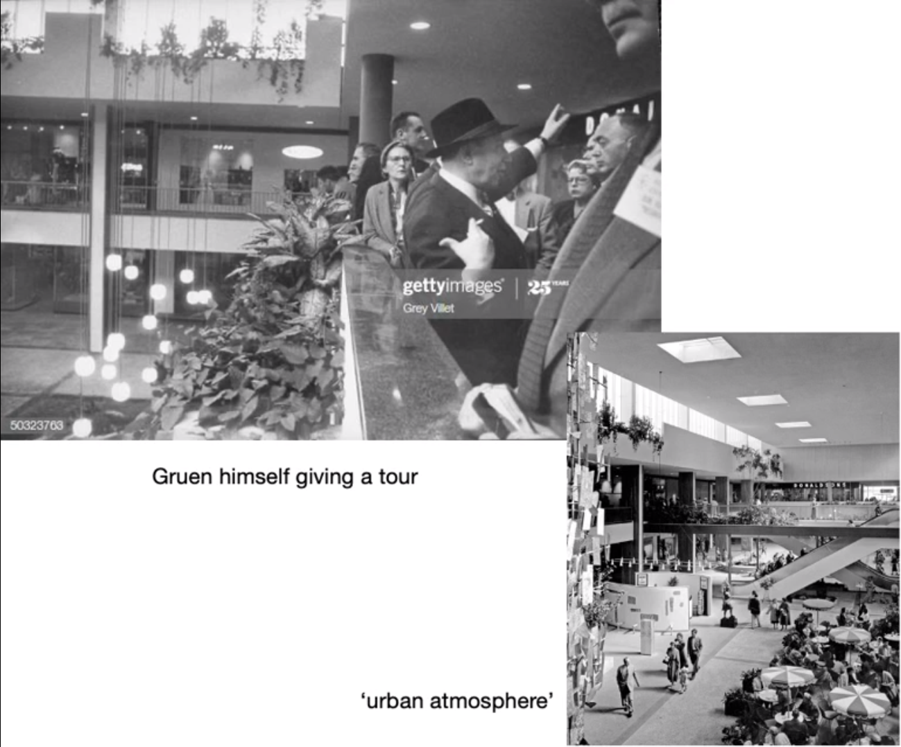

Gruen’s urban atmosphere, umbrellas when inside.